2 c Protein Structure
Proteins differ from one another in the number, type and sequence of their constituent amino acids. Each protein has a precise chemical composition and amino acid sequence, which leads to it having a unique 3D-shape.
The role of a protein in an organism depends on the proteins shape.
All proteins are regarded as being made up of a primary, secondary and tertiary structure while some also display a quaternary structure.

Primary Structure
Primary Structure describes the unique order in which amino acids are linked together by covalent bonding to form a protein.
Using three letter abbreviations, a bit of protein chain might be represented by, for example:

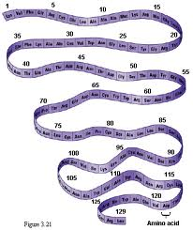

Secondary Structure
Secondary Structure refers to the coiling or folding of a polypeptide chain that gives the protein its 3-D shape. There are two types of secondary structures observed in proteins. One type is the alpha (α) helix structure. This structure resembles a coiled spring and is secured by hydrogen bonding in the polypeptide chain. The second type of secondary structure in proteins is the beta (β) pleated sheet. This structure appears to be folded or pleated and is held together by hydrogen bonding between polypeptide units of the folded chain that lie adjacent to one another.
- Secondary structure is created by the formation of hydrogen bonds between the oxygen from the carboxyl group of one amino acid and the hydrogen from the amino group of another.
- Secondary structure does not involve the side chains, R groups.

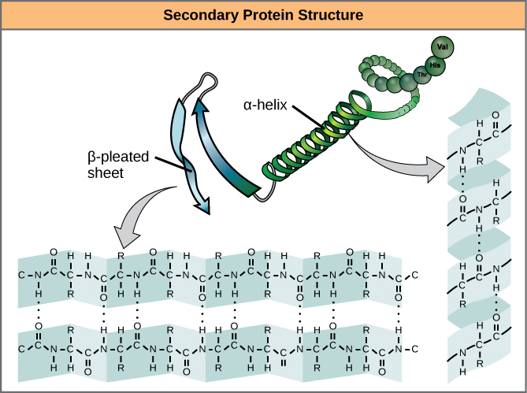

Tertiary structure
The term tertiary refers to the overall three- dimensional shape of a polypeptide.
The polypeptide chain (containing the alpha helix and beta pleated sheets) bend and fold over itself because of interactions among R-groups and the peptide backbone.
Interactions that cause tertiary organisation include:
  - Covalent bonds between sulphur atoms to create disulphide bonds (bridges)
  - Hydrogen bonds between polar side chains
  - Ionic bonds between positively and negatively charged side chains.
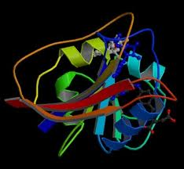
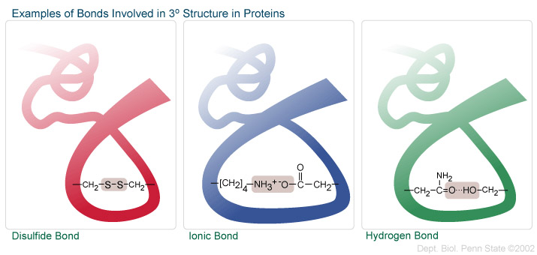

Quaternary structure:
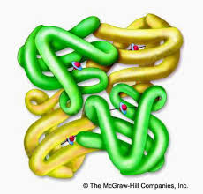
Quaternary structure only applies to proteins made from more than one polypeptide chain. Proteins made from a single polypeptide will not have a quaternary structure. In proteins with more than one polypeptide chain (often referred to as a polypeptide subunit), weak interactions between the subunits help to stabilize the overall structure.

